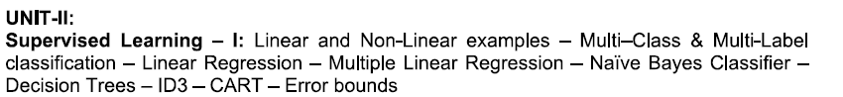

A linear model, also known as a linear regression model, is a statistical approach used to describe the relationship between a dependent variable and one or more independent variables.
It assumes a linear relationship between the variables, meaning that the dependent variable can be expressed as a linear combination of the independent variables. They can help you understand and predict the behavior of complex systems or analyze experimental, financial, and biological data in various fields such as statistics, economics, social sciences, and machine learning. They provide a simple and interpretable way to understand the linear associations between variables and make predictions based on the learned patterns.
The goal of a linear model is to find the best-fitting line or hyperplane that minimizes the difference between the predicted values and the actual values of the dependent variable.
A non-linear model is also a statistical model that does NOT assume a linear relationship between the dependent variable and the independent variables, meaning that analyzing more complex relationships from more complex and relatively large datasets is available in non-linear models with making curves, exponentials, logarithms, or interactions.

Examples of non-linear models
- Logistic Regression: Logistic regression is used when the dependent variable is binary or categorical. It models the relationship between the independent variables and the probability of an event occurring using a logistic function, which produces an S-shaped curve.
- Neural Networks: Neural networks are a class of non-linear models inspired by the structure and function of biological neurons. They consist of interconnected layers of nodes or artificial neurons and can model complex relationships by learning from large datasets.

Non-linear models in real world
Non-linear models are particularly useful in fields such as physics, biology, finance, image processing, and machine learning, where the relationships between variables are often more complex and not easily captured by linear models.
However, when the complexity increases by using non-linear models, it can be challenging to estimate and interpret the analyzed data or output, compared to linear models.

Main difference between linear and non-linear models
- Assumption about the relationship between the dependent variable and the independent variables
- Linearity from variables described by a straight line or a curved line
- Flexibility of whether allowing more complex and diverse relationships between variables or not
- Estimation such as OLS(Ordinary Least Squares for linear models and more advanced techniques such as optimization algorithms and iterative methods for non-linear models

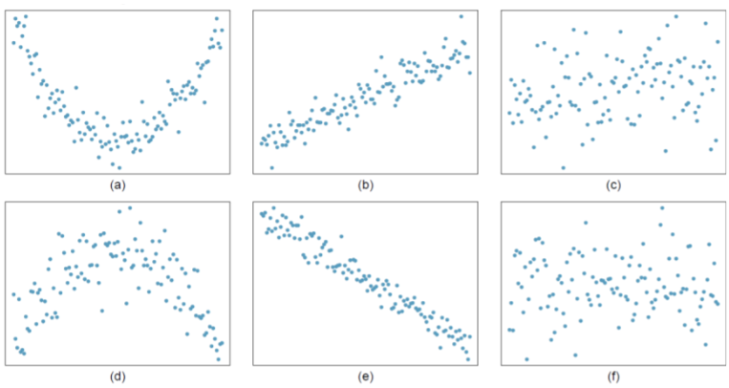

Multi-Class Classification
- Definition: In multi-class classification, an instance can belong to one and only one class from a set of more than two classes. In other words, the classes are mutually exclusive.
- Output: The model predicts a single label from multiple possible categories (i.e., one class per instance).
- Example: A model that classifies images of animals into one of three categories: cat, dog, or rabbit. Each image belongs to exactly one class.
  - Image 1: Cat
  - Image 2: Dog
  - Image 3: Rabbit
- Real-World Examples:
  - Handwritten Digit Recognition: The task is to classify images of handwritten digits into one of 10 classes (0–9).
  - Sentiment Analysis: A text can be classified as having a positive, negative, or neutral sentiment.
  - Disease Diagnosis: A medical condition may be classified into distinct categories like diabetes, heart disease, or healthy.

2. Multi-Label Classification
Definition: In multi-label classification, an instance can be assigned to multiple classes at the same time. This means the classes are not mutually exclusive.

Output: The model predicts multiple labels from a set of possible labels, meaning each instance can belong to one or more categories.

Example: A model that analyzes news articles and classifies them into relevant topics such as politics, economy, sports, or technology. A single article can belong to more than one category.
- Article 1: Politics, Economy
- Article 2: Sports, Technology
- Article 3: Politics, Technology

Real-World Examples:
- Image Tagging: An image may contain multiple objects, and the task is to tag all the objects in the image. For example, an image could be tagged with "cat", "dog", "tree" if all are present.
- Text Categorization: A document may belong to multiple categories, such as a research paper tagged as both "machine learning" and "natural language processing".
- Medical Diagnosis: A patient might have multiple diseases simultaneously, such as both hypertension and diabetes.

Key Differences:
Aspect | Multi-Class Classification | Multi-Label Classification
Number of Labels per Instance | One label per instance (single class). | Multiple labels per instance (one or more classes).
Classes | Classes are mutually exclusive. | Classes are not mutually exclusive.
Output Format | One-hot encoding (e.g., [0, 0, 1] for three classes). | Binary vector or set of labels (e.g., [1, 0, 1, 1] for four labels).
Prediction Goal | Identify the single most likely class. | Identify all relevant labels for an instance.
Examples | - Animal species classification (cat, dog, rabbit).  - Handwritten digit recognition (0–9). | - Image tagging (cat, dog, tree in one image).  - Text categorization (tech, finance, health).

Challenges:

Multi-class Classification:
- Requires a clear distinction between classes, which can be limiting if some classes are ambiguous.
- The performance may drop if classes are imbalanced (e.g., if some classes have very few examples).

Multi-label Classification:
- It is more complex since the model must predict a combination of labels.
- It involves handling dependencies or correlations between labels (e.g., some labels may often occur together, like "dog" and "animal").
- Evaluation metrics differ (e.g., precision, recall, and F1-score are often averaged over multiple labels).
Both approaches are widely used in various fields, and the choice between multi-class and multi-label classification depends on the nature of the task at hand.

Decision Trees---------------- https://logicmojo.com/decision-tree-machine-learning

Navie Bayes--- https://www.analyticsvidhya.com/blog/2017/09/naive-bayes-explained/

